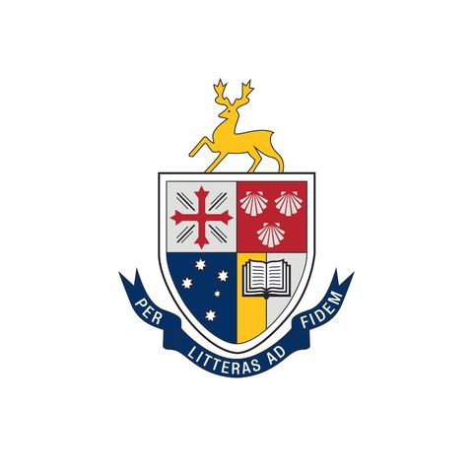

Social Media Intern 2026
APPLICATION FORM

Name:

Thank you for applying for appointment as Social Media Intern for 2026. This application form is designed to allow you the opportunity to provide information that will assist your application, and to assist the members of the Selection Panel to form their recommendation to the Head of College who will make the appointments. Please fill it in thoughtfully and attach a copy of your latest academic transcript.

The Social Media Intern forms part of the student service team and plays a key role in marketing the culture of Lincoln College, by capturing and sharing key moments in student life throughout the year. A Position Description is included with this form. In completing the form please shape your responses so that they address the requirements of this PD. Please limit your responses to the space allowed.

Your application and associated documentation is due by 10am, Monday 17 November 2025. Please submit your application via email to admin@lincoln.edu.au Late applications will not be considered.

Applicants will be notified of the outcome by Friday 28th November 2025.

Privacy notice: The information on this form will be made available only to Selection Committee. Once appointments for 2026 have been made, the applications of successful applicants will be kept on file until the end of 2026; the applications of those not appointed will not be kept.

- Why do you wish to be the Social Media Intern?

- Comment on the strengths, qualifications, attributes, skills and relevant experience that would equip you to do this role well.

- How do you think the Social Media Intern position will develop in 2026 if you gain the position?

- Lincoln College is a collection of many groups of students with diverse interests, yet it prides itself on being a community. What are some of the ways you might try to ensure all student interests are well represented in the College’s social media?

Please attach a scan of your full academic transcript
Applications will not be processed without this document.

POSITION DESCRIPTION

Name of position | - Social Media Intern
Accountable to | - Head of College, through the Marketing Manager
Position purpose | - Coordination, promotion and posting of the College’s social media accounts, specifically Facebook, Instagram and Linked In  - Contribute to sharing the positive culture at college with a wider audience
Essential criteria | - Satisfactory rate of academic progress  - Managing the Lincoln College Instagram Account under supervision of the Marketing Manager  - Record of positive contribution and cooperation at College  - Strong written communication skills and knowledge of current social media trends  - Strong organisational skills with a demonstrated ability to meet deadlines and attend to detail  - High level of personal initiative and integrity  - Availability to support college life, by being present at weekly Formal Dinners, HTC sports, functions, panels, House Cup, and any other activities on offer, in order to capture relevant moments and post them as appropriate
Responsibilities and Duties | - Plan, implement and evaluate effective ways to share and capture involvement of all students, throughout the College year  - Meet regularly (at least once per term) with the Marketing Manager to discuss progress of role and future initiatives  - Publishing two pieces of engaging content on both Instagram + Facebook per week, covering all major college events; including a fortnightly “Shout Out Thursday” featuring current College students.  - Using relevant Insta-supported apps for engaging contents  - Capture moments/emotions to connect college’s friendly inclusive community  - Take small video snippets [8-10s] for Archive, as much as possible catching relevant moments/stories; at least 3 of them for each event  - Attend to administrative matters  - Other duties as discussed throughout the year
Remuneration | - $2000 per calendar year, paid in instalments at the end of each semester
Tenure | - One academic year
Other conditions | - Student Leaders commit to keep and uphold all the values and rules of Lincoln College  - Position is subject to the satisfactory completion of your university subjects in the semester prior to taking on this role.  - A performance review will take place at the end of semester 1 and the continuance of the role will be dependent on the satisfactory outcome of the review.  - Where course requirements require an absence of more than 3 weeks, the role may be renegotiated with the Dean of Students and proof will be required.  - If you terminate your position of employment with the College, a minimum of 2 weeks’ notice in writing is required.  - The position is part-time with primary responsibilities being conducted after hours, in the evenings and on weekends.  - You are entitled to take leave during the university breaks in accordance with your course structure.  - An undertaking to abide by the “Code of Conduct” and all policies and procedures as set out in the Student Handbook.  - Availability for some planning and training in the week prior to O-Week next year  - Actively support college life, by being present at weekly Formal Dinners, HTC sports, functions, panels, Corridor Cup, and any other activities on offer.

